Junior Maths Extension Course

Investigations

Contents
Contents
Collatz Conjecture 3
Benford’s Law 4
Golden Ratio – finding through using the Quadratic Formula 6
Proving 1=2 7
Square numbers investigation 8
Pascal’s Triangle 9
Forming the triangle 9
The most common way to form it 10
What do we notice about Pascal’s Triangle? 11
Pascal’s Triangle with probability 11
Combinations 12
Binomial Expansions 13
Percentage of odd numbers 13
Fractals 15
Koch Curves 16
Fractal cut-out card activity 17
Mandelbrot Set 18
Alfred Moessner – mathematical series investigation 20
Zero to the power of zero 23
Multiplicative persistence 24
Buffon’s Needle 25
Ramanujan’s Summation 26
Luke Manson’s intro to induction 28
Solution 29
Proof by induction: 30

Collatz Conjecture
https://www.youtube.com/watch?v=094y1Z2wpJg&ab_channel=Veritasium
Pick any number and follow these steps:
If the number (N), is odd, multiply it by 3 and add 1 ($3N + 1$)
If the number is even, divide it by 2 ($\frac{N}{2})$
Repeat this over and over.
This can be written as: 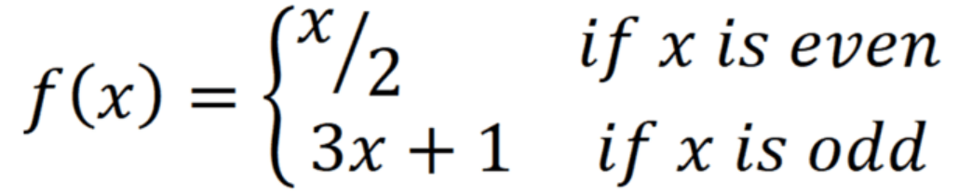
What do you notice? Everyone should now choose a different number and repeat the algorithm. What happens?
The Collatz Conjecture suggests that this will happen to all numbers, but it has remained a conjecture as no-one has been able to prove it. What seems like a simple problem is actually beyond all mathematicians so far. That hasn’t stopped many studying it, but so far it appears to be a bit of a career-killer for those who have studied it.

Let’s examine the data in two ways.
First, plot all of the points on a line graph. For example, below is a graph of the path the series takes when we start with 7 (7 – 22 – 11 – 34 – 17 – 52 – 26 – 13 – 40 – 20 – 10 – 5 – 16 – 8 – 4 – 2 – 1).
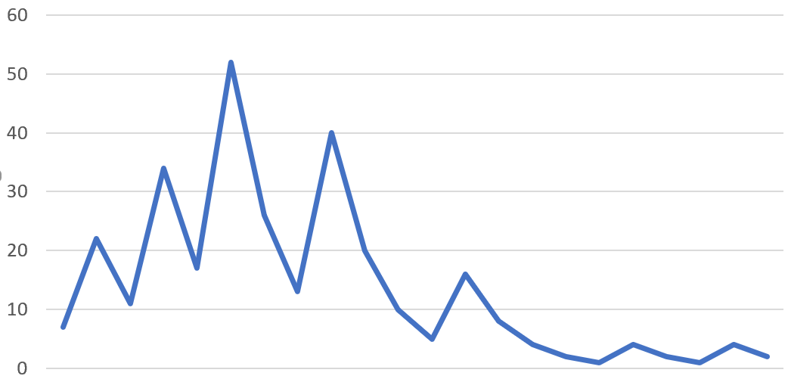
Put as many series as possible on the same graph. Is there any kind of pattern?

Do numbers that reduce to 1 quickly have anything in common?

Second, we will look at the first digit of each number in the series and record the frequency of each number from 1-9. We can then plot a bar graph showing the relative frequencies.
For example, the distribution of digits for the series starting with 7 is:
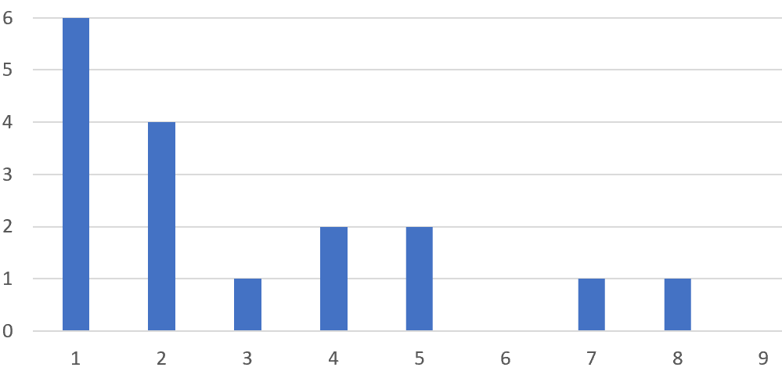
Combine your data with that of everyone else in the class. What are the relative frequencies (probabilities) of each number?

Benford’s Law
The first digits follow a distribution called Benford’s Law. While you might expect these numbers to be uniformly distributed, with a probability of each occurring as being $\frac{1}{9}$.
However, it turns out that in practice the observed probability in most large sets of numbers follows Benford’s Law. This law is even used in financial investigations, as if a company’s financial statements do not follow Benford’s Law, there is a strong chance that there is some form of fraud going on.

Benford’s Law:
$P\left(d\right)=\log_{10}{(\frac{d+1}{d})}$, where $d$=first digit of a number
Don’t worry too much about the Log, we’ll cover those in more depth later. They just make use of the fact that any number can be written as another number raised to a power, such as $100={10}^{2}$, or $32={10}^{1.505…}.$Basically, if rearranged the equation, it means that ${10}^{P(d)}=\frac{d+1}{d}$.
Computing $P(d)$ for $d=1$ to 9, gives:
d | P(d)
1 | 0.3
2 | 0.18
3 | 0.12
4 | 0.1
5 | 0.08
6 | 0.07
7 | 0.06
8 | 0.05
9 | 0.05

Notice that P(d) is not uniformly distributed. Also, that nearly 50% of numbers will begin with 1 or 2. Also notice, that any set of numbers that follows Benford’s Law the first digit is likely to be small.
Obviously, numbers won’t always follow this distribution exactly, but they will tend to be pretty close. For example, below is a graph of the distribution of first digits from the 2017 GDP figures by country.
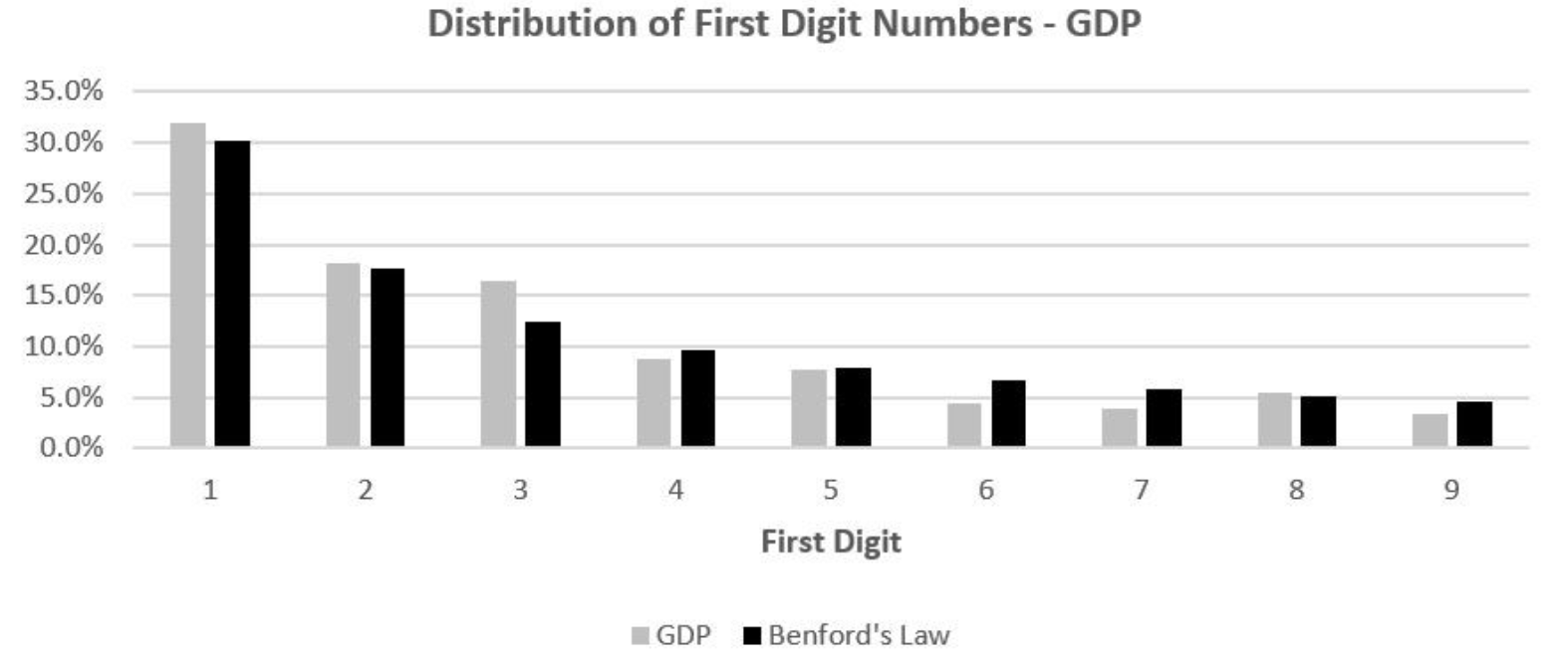
Task:
Using Excel, find the first 100 digits of the Fibonacci sequence. Count up the frequency of each first digit and calculate the proportion of each. Plot in a bar chart. How closely does it follow Benford’s Law?
Formulas:
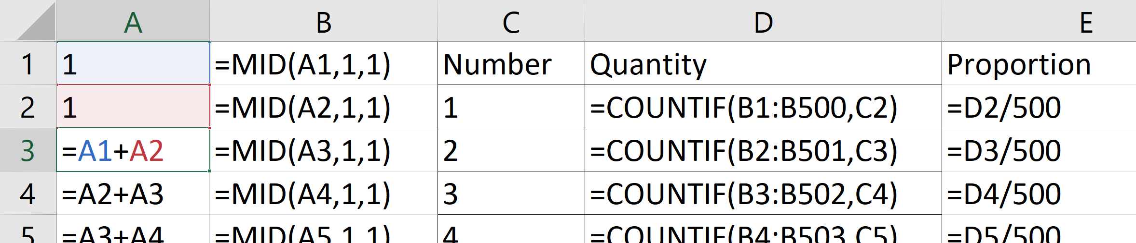

Golden Ratio – finding through using the Quadratic Formula
Start with a 1 x 1 square, and then add on a rectangle at one end. This rectangle will have a height of 1 and width of x. The ratio of the sides of this rectangle needs to be the same as the ratio of the side in the new, large, rectangle we have created.
i.e.
1
x
1
1

Now we can form an equation linking the two rectangles and simplify to find the Golden Ratio.
$$x+1 :1=1:x \\ \frac{x+1}{1}=\frac{1}{x} \\ x^{2}+x=1 \\ x^{2}+x-1=0$$
Use the Quadratic Formula to solve:$$x=\frac{-1±\sqrt{1^{2}-\left(4×1×-1\right)}}{2} \\ x=\frac{-1±\sqrt{5}}{2}$$
Now we know the length of the longer side of the large rectangle must be the Golden Ratio, so we just add 1 to each side:$$x+1=1+\frac{-1±\sqrt{5}}{2} \\ x+1=\frac{1±\sqrt{5}}{2}$$
The Golden Ratio must be positive, so disregard the negative part of the answer, giving:$$x+1=\frac{1+\sqrt{5}}{2}$$
The Golden Ratio is therefore: $$\frac{1+\sqrt{5}}{2}=1.618…$$

Proving 1=2

First, set two different variables to be equal:
$$a=b$$

Multiply both sides by a:
$$a^{2}=ab$$

Subtract b² from both sides:
$$a^{2}-b^{2}=ab-b^{2}$$

Factorise both sides:
$$\left(a+b\right)\left(a-b\right)=b(a-b)$$

Simplify by dividing both sides by a-b:
$$a+b=b$$

Since a=b:
$$2b=b$$

Dividing by b:
$$2=1$$

So why does this happen?
If you think about it, when you divide both sides by (a-b), you are actually dividing by zero, as a and b are equal. You can’t do this, shouldn’t do this! When you divide by zero, strange things happen.

Square numbers investigation
Looking to get students to see the pattern of increasing square numbers.
Start by listing first 10 square numbers: 1, 4, 9, 16, etc.
What is the difference between them? (Increasing odd numbers)
Why does it increase by this each time?
Show using algebra: ${(n+1)}^{2}-n^{2}=n^{2}+2n+1-n^{2}=2n+1$
So for example, the next square number after 100 will be 20(10)+1 greater = 121.
This can also be thought of as the sum of the two numbers being squared. i.e. the difference between 10² and 11² is 10+11.
Show this visually by drawing increasing squares:
Notice how each time we increase the square dimension by one, the area increases by an L shape. This is as high and wide as the previous square, plus one extra block for the corner. Hence 2n+1.

Pascal’s Triangle

Forming the triangle
Draw a pyramid of circles:
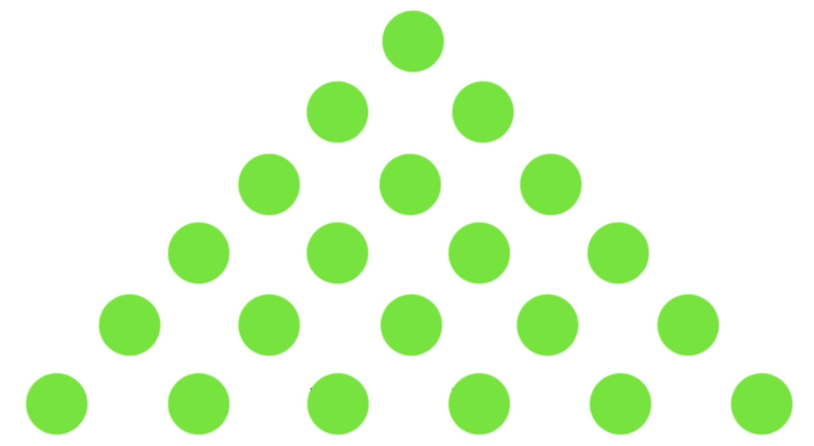
Colour the top one in blue and join each circle with the two adjacent ones on the row below it:
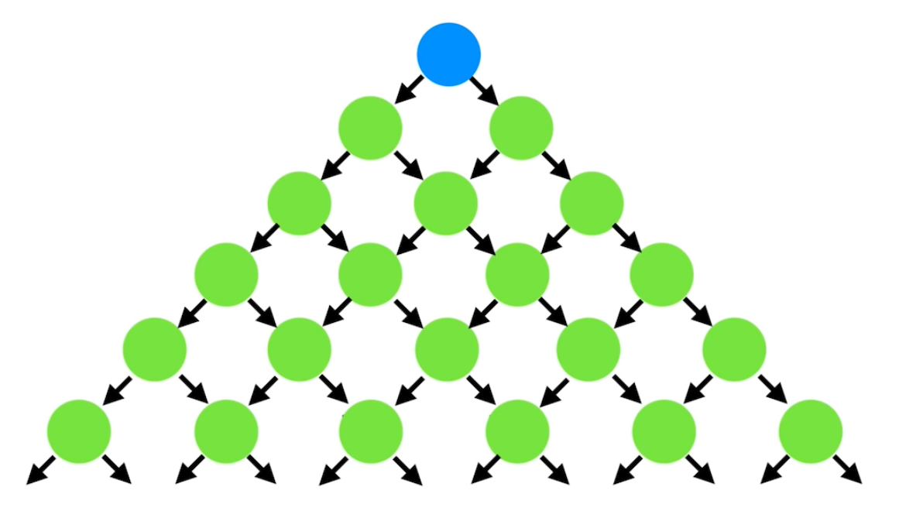
Colour another, anywhere in the pyramid, orange:
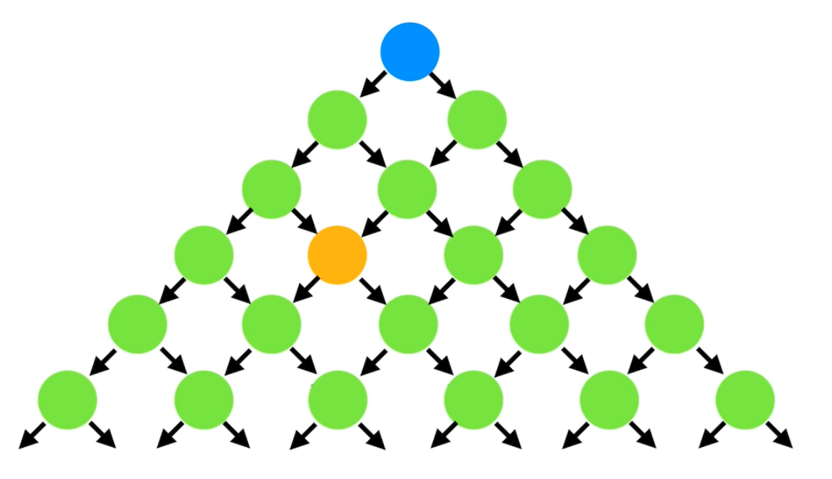
How many paths are there from the blue circle to the orange circle?
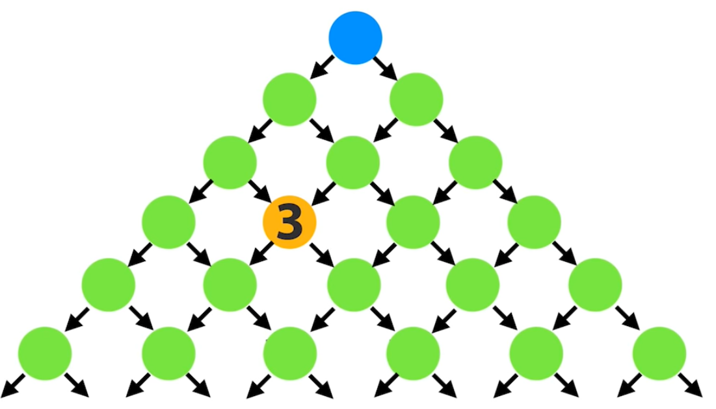

At any point, to get to orange circle, we need to pass through either of the two circles above it. So, we know that if we add the number of paths to each of those two circles, it will give all of the possible paths to the orange circle:
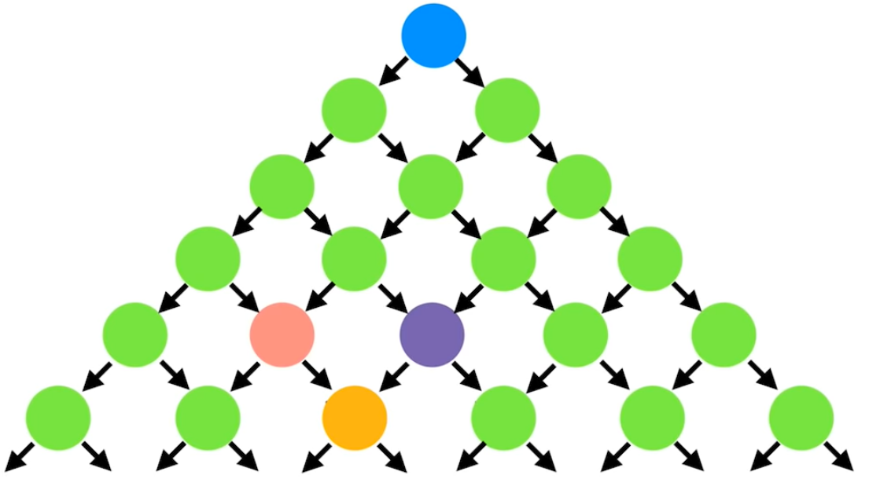

Working out all these paths gives us Pascal’s Triangle:
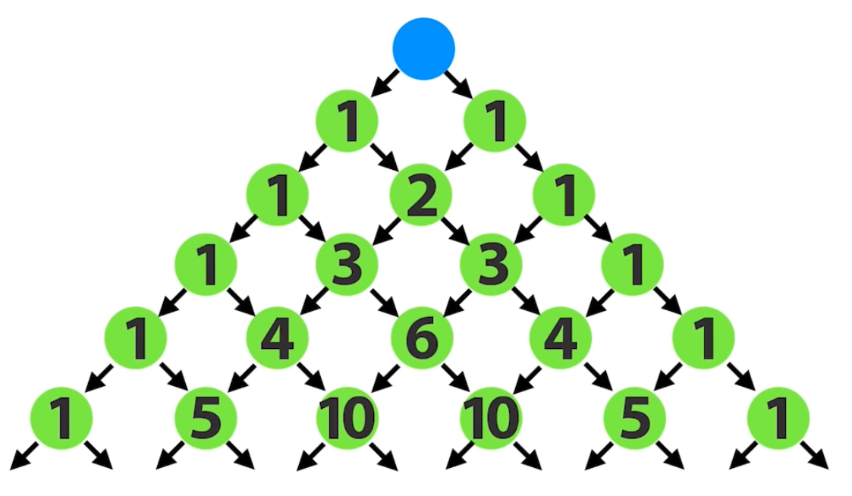

The most common way to form it
Start by forming it. In the first row write a one.
To find the second row, visualise two zeros outside of the 1.
0 1 0
To get the numbers in the next row we just add the two numbers above to the left and right.
0 1 0
1 1
Repeat for each new row, always visualising a zero outside the 1s on the edge:
1
- 1
1 2 1
1 3 3 1
1 4 6 4 1
And so on…

What do we notice about Pascal’s Triangle?
Get students to look and discuss amongst themselves for a few minutes before taking feedback from the class. Encourage them to not just look at the numbers but to also look for random patterns and sums.
Things they may notice:
- It is symmetrical. Notice that if you drew a line of symmetry down the middle, the numbers either side of it are the same
- The second column is made up of the counting numbers (1, 2, 3,4…)
- The third column is made up of the triangle numbers (1, 1+2, 1+2+3, etc)
- The fourth column is made up of tetrahedral numbers
- The sum of each row is a power of 2
- Each row gives the digits of powers of 11 (11, 121, 1331, etc)
- If a row starts with a prime number, all of the other numbers in that row are divisible by that prime number
- If you take any number in the second column, the square of the number is equal to the sum of the numbers on its right and bottom right
- By adding diagonals you can get the numbers in the Fibonacci sequence:
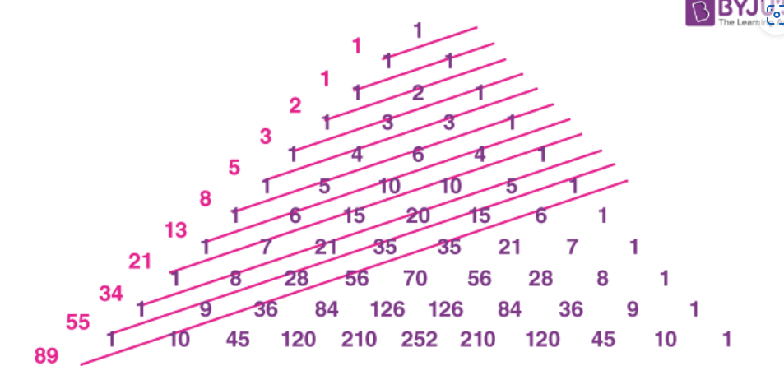

Pascal’s Triangle with probability
Suppose if we are tossing a coin. If we toss it once, there are only two possible outcomes: Heads or Tails.
If we toss it twice, there are three possible outcomes: one way of getting two Heads, two ways of getting a Head and a Tail, and one way of getting two Tails.
Compare this to the numbers in Pascal’s Triangle:
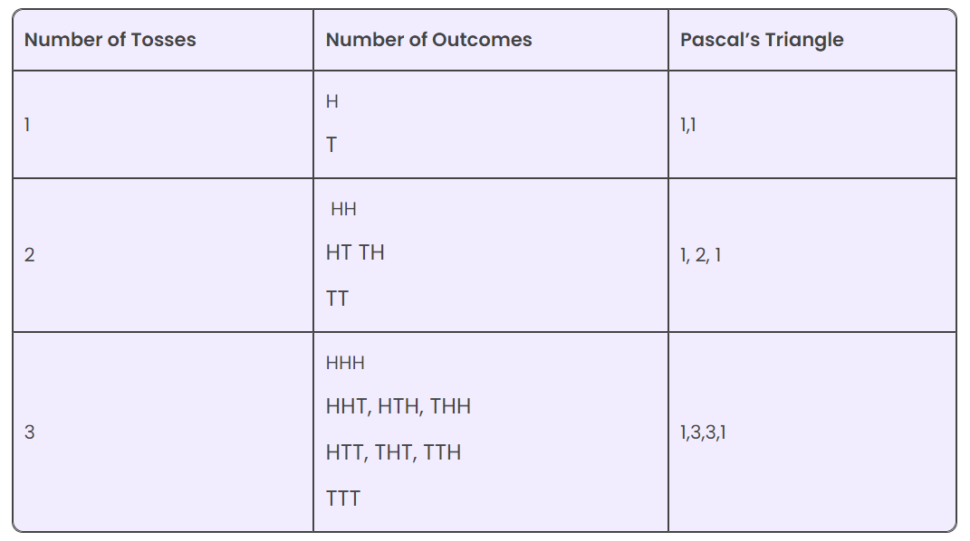

Combinations
We can use Pascal’s Triangle to solve problems involving groups. For example:
If there are 6 people in a room and they all shake hands, how many handshakes will there be?
Consider each handshake as a group of 2 people. When selecting groups, there are 6 people for the first person followed by 5 possibilities for the second. 6 x 5 = 30. However, in a group the order we select members doesn’t matter. i.e. AB is the same as BA.
Therefore, we need to divide by how many different orders the group members could have been selected.
In this example, there are two possible ways: A then B, or B then A.
Therefore, there will be $\frac{6×5}{2}=15$handshakes.

How many handshakes would there be if there were 5 people? 8 people?

Next, what if we wanted to put people into groups of 3 instead. How many possible groups could we form from 6 people? What about from 5 people?

Finally, where can you see these numbers in Pascal’s Triangle?

Use your findings to answer these questions:
How many different groups of 5 people could you form from a population of 8?
How many different groups of 3 people could you form from 7 people?

Binomial Expansions
Another use of Pascal’s Triangle is in expanding brackets with two terms, such as ${\left(a+b\right)}^{n}$.
When you do the expansion, the terms will follow a pattern where they start $a^{n}$ and then $a^{n-1}b, a^{n-2}b^{2}$, and so on until $b^{n}$. The coefficients of these terms can be found on the nth row of Pascal’s Triangle.
For example: ${\left(a+b\right)}^{3}=a^{3}+3a^{2}b+3ab^{2}+b^{3}$
Notice that the numbers in the third row of Pascal’s Triangle are 1, 3, 3, 1. Also note that we are starting with the very top row (the single 1) as being called row zero.
Use this to expand the following:
- ${\left(x+2\right)}^{5}$
- ${(2x+y)}^{4}$
- ${\left(2x-1\right)}^{4}$
- ${\left(x^{2}+x\right)}^{3}$
- ${(3x+2y)}^{4}$
- ${\left(x+\frac{1}{x}\right)}^{5}$
- ${(2x+\frac{1}{x^{2}})}^{4}$
Much harder problems:
- Find the coefficient of the $x^{2}$ term in ${(x^{2}+\frac{1}{x})}^{10}$
- Find the term independent of x in ${(2x^{2}-\frac{3}{x})}^{6}$
- Find the term independent of x in ${\left(3x^{2}-\frac{1}{3x}\right)}^{12}$

Percentage of odd numbers
What percentage of numbers in the first 128 rows of Pascal’s Triangle will be odd?
Look for a pattern in the early rows and see if it can be generalised to get the number.
This will require students to work out how many numbers in total in the 128 rows (it is the 128th triangle number, so found by $\frac{{128}^{2}+128}{2}$). Also, they hopefully will spot the pattern that the number of odd numbers triples each time you double the number of rows. So, starting with one odd number in row 1, then 3 after 2 rows, 9 after 4 rows, and so on, they can easily get the number of odds.
To follow this up, get students to draw Pascal’s triangle with lots of rows (or give them a copy), and shade in those circles with even numbers. Notice the pattern. Called Sierpinski’s gasket.

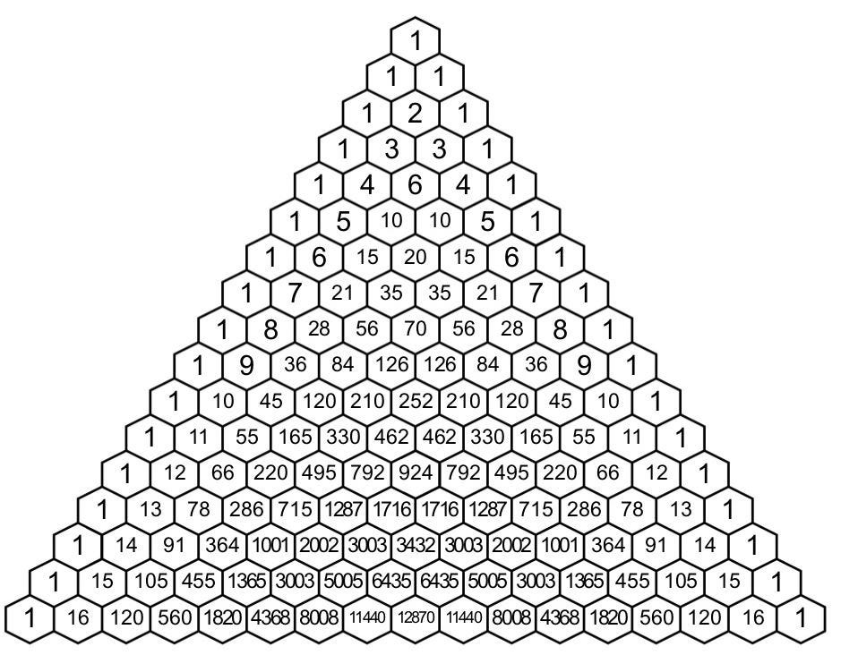


Fractals
Consider an equilateral triangle.
What happens if we remove an equilateral triangle from the centre? And then repeat this for the remaining triangles? And then repeat over and over again? We get the Sierpinski triangle!
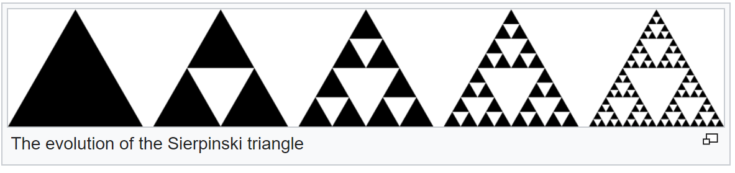
Notice that the area of the shape is getting smaller and smaller (because we are removing parts of it) but the edge is getting longer and longer. If we continued this forever, we would end up with a shape with zero area and infinitely long edges!
If we did this in 3-dimensions with a cube, we get a Menger Sponge. Taken to infinity, it would have zero volume and infinite surface area.
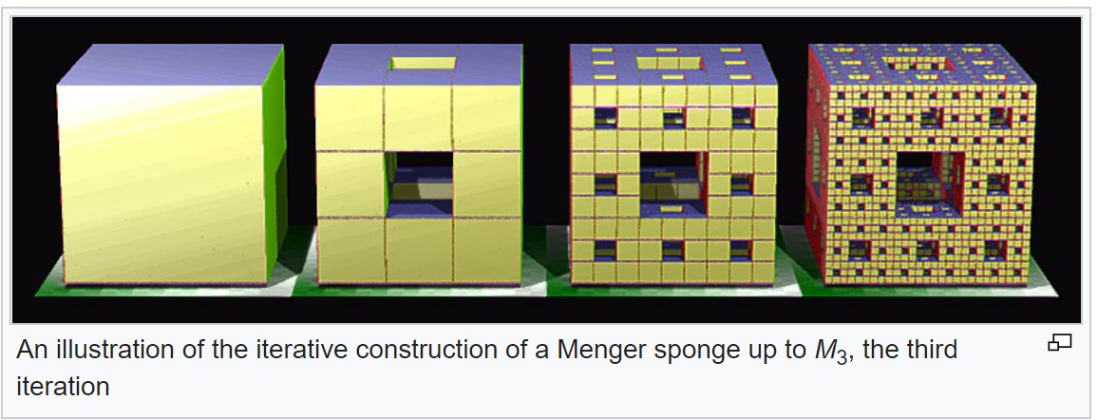


Koch Curves
More great activities at: https://fractalfoundation.org/
In this exercise, students learn to transform a simple shape into a complex fractal curve by repeating the same operation at smaller and smaller scales and track changes to the perimeter at each step. The resulting shape is highly complex, has a large perimeter and is roughly similar to natural fractals like coastlines.
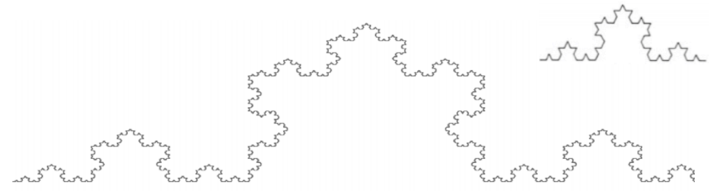
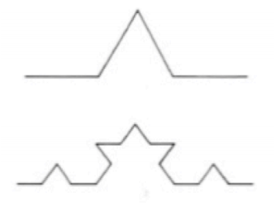

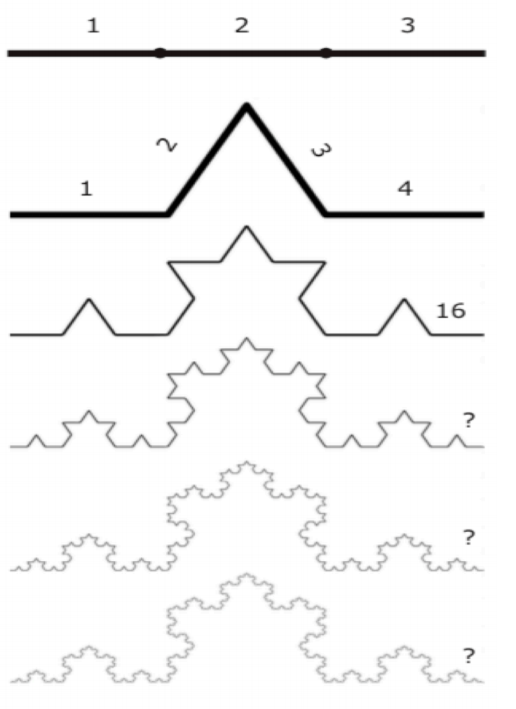
The Koch Curve is a fractal that starts with a simple pattern made from a line that is divided into three equal parts.
First, erase the middle segment and replace it with an upside down “V” shape. Now the pattern is made up of four line segments.
Next, we repeat the process. Each of those four lines is divided in thirds and the middle segment is replaced with a “V”.
There are now 4 x 4 or 16 line segments. Remember: fractals are never-ending patterns made by repeating the same idea over again.
Next, we replace each of the 16 line segments with the same pattern again. Each time we do this, the curve gets more jagged and complicated, and its length – or perimeter – gets bigger. Perimeter = is the distance around a two-dimensional shape, or the measurement of the distance around something.
Eventually, the pattern starts to look like a fractal in nature like a coastline, or the edge of a snowflake.

Fractal cut-out card activity
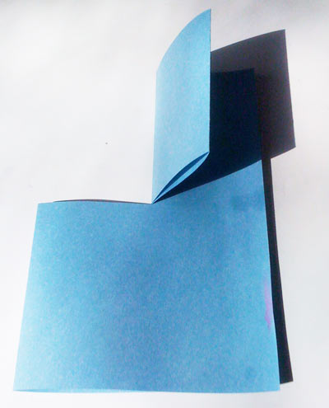
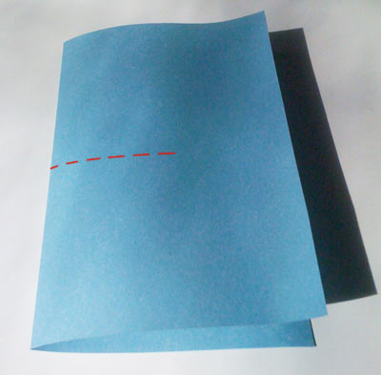
Take one piece of paper and fold it in half, so it looks like a book.
Cut through the folded edge along the dotted line above. The cut should start half-way up and down the fold and go half way to the right along the folded paper. Now fold over one half and crease, as shown.
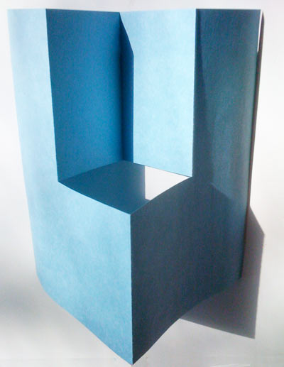
The next step is a little tricky but critical. Open up the folded-over flap, and fold it inside itself. You should end up with your paper looking like this:
You have now completed the basic step to create the fractal cutout, and all you have to do now is keep repeating this process again and again.

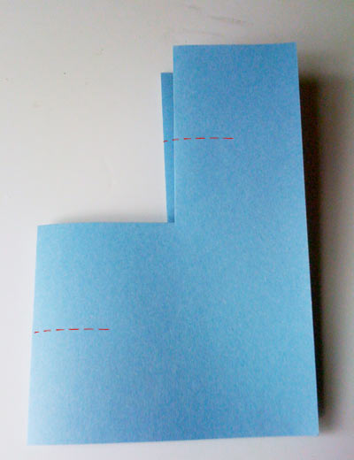
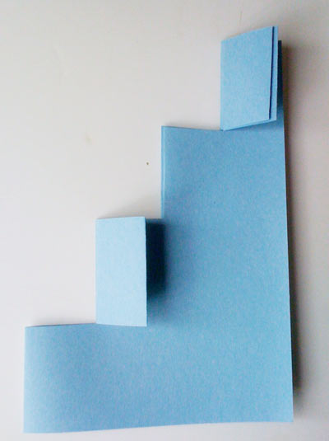
Now make two cuts, half way through each of the folded edges. The cuts will be half as long, and again the cuts should be half way up and down each edge and go only half way through the piece. Be careful not to cut too far.
Once you’ve made these cuts, fold over the and crease the flaps. How do you know which ones to fold over? You want to end up with something looking like a staircase.
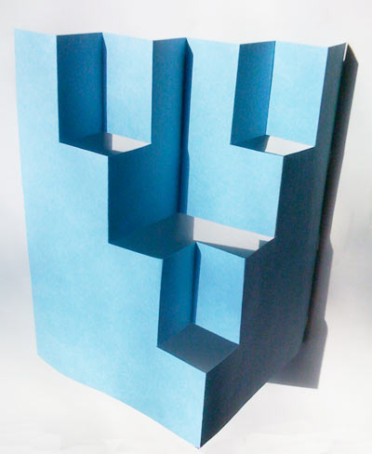
After you’ve folded the flaps, you must remember to open the flaps up and fold them inside themselves. This what your paper should look like now:

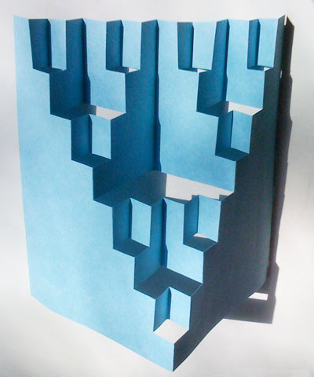
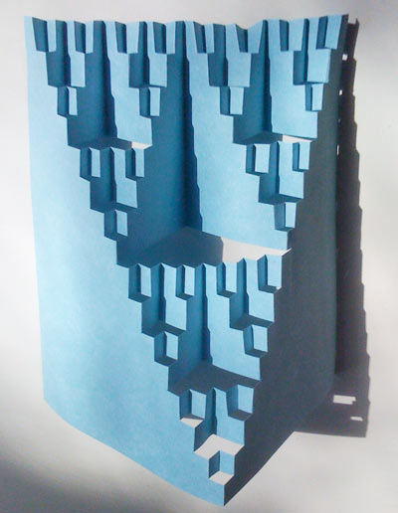
Repeat the same cutting, folding and inverting, but this time you need to make four cuts. After folding and flipping the flaps inside themselves, you’ll end up with this:
If you want, you can repeat this process one more time, making eight cuts. After cutting, folding and inverting, you end up with the final stage. After this point, there are too many layers to cut easily.

Mandelbrot Set
Now we look at doing something similar with numbers, where we will be replicating the work of Benoit Mandelbrot.
Start by giving students the function ${f\left(x\right)=x}^{2}+c$
Get them to choose a value for c between -1 and 1.
They then make x=0 and calculate the value of the function (which will be c)
Then, substitute this result back into the function as the value for x.
For example, set c = 1, so the function is $f\left(x\right)=x^{2}+1$
$$f\left(0\right)=0+1=1 \\ f\left(1\right)=1^{2}+1=2 \\ f\left(2\right)=2^{2}+1=5 \\ f\left(5\right)=5^{2}+1=26$$
Or if we set c = 0.9, giving $f\left(x\right)+0.9$$$f\left(0\right)=0+0.9=0.9 \\ f\left(0.9\right)={0.9}^{2}+0.9=1.71 \\ f\left(1.71\right)={1.71}^{2}+0.9=3.8241$$
Repeat this a few times and see what happens. Is it trending towards a value or is it escaping to infinity?
Compare c = 0.5 to c = -0.5.
We could calculate a lot of these and plot on a number line to see if there is a pattern.
(This would be a lot easier with programming, which enables us to introduce Python.)

Mandelbrot actually looked at using complex numbers, which have two components to them, enabling him to plot them on a graph. For those who have done anything with complex numbers, try setting c to being complex and then calculate a few iterations – it takes time!
Good Numberphile video: What's so special about the Mandelbrot Set? - Numberphile - YouTube
And a totally trippy video of colourised Mandelbrot zoom: Mandelbrot Zoom 10^227 [1080x1920] - YouTube

Alfred Moessner – mathematical series investigation
The Moessner Miracle. Why wasn't this discovered for over 2000 years? - YouTube

List the counting numbers in order: 1, 2, 3, 4, 5, 6…
If you skip every second one we get: 1, 3, 5, 7…
Summing as we go we get the square numbers
1 2 3 4 5 6 7 8 9 10 11 12
1 4 9 16 25 36

But what would happen if skipped every third number, then every second number in the next row? We would need an extra row, but look at what happens:
1 2 3 4 5 6 7 8 9 10 11 12
1 3 7 12 19 27 37 48
1 8 27 64
We get the cubic numbers!

Students check if this holds for every fourth number and every fifth number. (Teacher hint: it does)

Time for a visual proof of the first two:
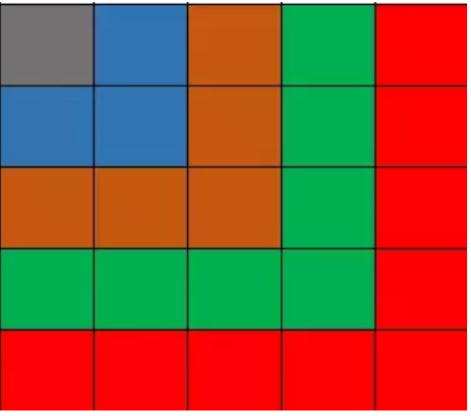
This comes from Pythagoras (or the Pythagoreans). Each L-shape is called a gnomon. You can see that by adding on an L-shaped gnomon it is effectively adding the next odd number, and it creates a square, therefore the area (or sum of the first n gnomons) will be a square number.

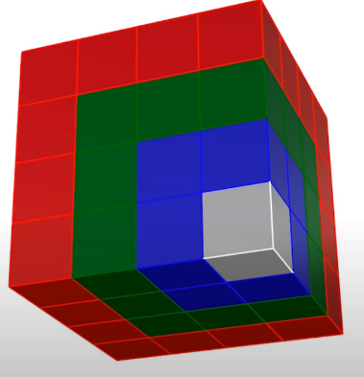

It is a bit harder to visualise what is happening with the cubic numbers though. Can you do it?

Hopefully you can see that we are building up a 3d cube by adding a wrapper. Count how many small cubes are in each wrapper. Notice the pattern and how it appears in our series?
If this leads to a discussion about higher-dimensions, here is a great video by Carl Sagan:
4th Dimension - Tesseract, 4th Dimension Made Easy - Carl Sagan - YouTube

Finally, investigate what happens when you highlight the first number (i.e. skip none), then skip one and highlight the next number. Then skip two, then skip three, and so on. Do the same on each row below. What numbers do you get appearing at the start of each row?
(Teacher: it is the factorials)
1 2 3 4 5 6 7 8 9 10 11 12 13
2 6 11 18 26 35 46 58 71
6 24 50 96 154 225
24 120 274
120

Notice at this point that the numbers crossed out in the top line are triangle numbers, while the leading numbers are factorials. i.e. one set of numbers is 1+2+3+… and the other is 1x2x3x…

Revisiting the original series, notice that the numbers crossed out are 1x2, 2x2, 3x2, 4x2, etc, while the numbers revealed will be 1^2, 2^2, 3^2, 4^2, etc.
1 2 3 4 5 6 7 8 9 10 11 12
1 4 9 16 25 36

Does this hold for the cubic numbers too?
1 2 3 4 5 6 7 8 9 10 11 12
1 3 7 12 19 27 37 48
1 8 27 64

The top row has 1x3, 2x3, 3x3, 4x3 while the bottom numbers are 1^3, 2^3, 3^3, 4^3, etc.

Now let’s investigate further!

What about if the top row numbers are the square numbers?
1 4 9 16 25 36 49 64 81 100 121 144
(Not sure where that goes)

Now let’s look if we recognise anything in the patterns. Let’s look at the 5th powers pattern:
1 2 3 4 5 6 7 8 9 10 11 12
1 3 6 10 16 23 31 40 51 63
1 4 10 26 49 80 131 194
1 5 31 80 211 405
1 32 243
Have a look at the first triangle and rotate it 45 degrees to the left. What do you notice? Pascal’s Triangle!

It is missing the column of 1s down the right-hand side. What happens if we add the 1s across the top?
1 1 1 1 1 1 1 1 1 1 1 1
1 2 3 4 5 6 7 8 9 10 11 12
1 3 6 10 16 23 31 40 51 63
1 4 10 26 49 80 131 194
1 5 31 80 211 405
1 32 243

Notice how adding each 1 gives the row of counting numbers, which is our original first row.

Zero to the power of zero

What is 0 to the power of 0? - YouTube
Start by recapping indices and what it means to say $a^{m}$
Then look at the index rules for multiplication and division, eventually getting to $a^{0}=1$
Then look at zero to the power of anything, what does it equal.
So, given that anything to the power of zero is equal to one but zero to the power of anything is zero, what will zero to the power of zero equal?
Allow discussion and arguments!

Create a table on the board with values, starting at 1, doing down by 0.05 (0.1, depending on how many in the class). Get each student to calculate one value, with that number to the power of itself.
1^1 | 1
0.95^0.95
0.9^0.9
Etc

As the values come in, keep asking what the students notice. When does it start to behave unexpectedly?
Keep going and see what they think.
Can even put values into Excel and graph it to see the pattern visually.

Introduce the idea of limits, and how functions will behave near a point rather than at a point.
$$\lim_{n→0}{n^{n}}$$

Multiplicative persistence
When you have a number with multiple digits, if you multiply all of the digits together it will create a new number.
E.g. $343=3×4×3=36$
Multiplicative persistence is the process of repeating this until you get a single-digit number, at which point we stop. Each original number will have a score, which is how many steps it takes to reach the single-digit.
E.g.
$$343=3×4×3=36 \\ 36=3×6=18$$$18=1×8=8$
Therefore, 343 has a multiplicative persistence of 3.

Pick a 4-digit number and check its multiplicative persistence? What is the highest score you can find?

What about 5-digit numbers? 6-digit numbers? Have a competition in class to see who can get the highest score for each.

What do you think the largest score ever found might be?

What's special about 277777788888899? - Numberphile - YouTube

Buffon’s Needle
(2) Counter-Intuitive Probability: Buffon's Needle Problem. Pi (π) From Probability! - YouTube

Ramanujan’s Summation

A proof that $1+2+3+4+…+∞=-\frac{1}{12}$

Indian mathematician Srinivasa Ramanujan came up with this crazy sounding claim by combining three different series:
$$A=1-1+1-1+1-… \\ B=1-2+3-4+5-6+… \\ C=1+2+3+4+5+6+…$$

It starts with Grandi’s series, where we find the sum of the series where 1-1+1-1 is repeated an infinite number of times.
$$A=1-1+1-1+1-1+1-…$$
Try subtracting this sum from1:
$$1-A=1-\left(1-1+1-1+1-1+…\right) \\ 1-A=1-1+1-1+1-…$$
Notice that the right-hand side is now the same as the original series, A.
$$1-A=A$$
Rearranging and solving for A, we get:
$$2A=1 \\ A=\frac{1}{2}$$
So according to this, $1-1+1-1+1-1+…=\frac{1}{2}$

The second series is $B=1-2+3-4+5-6+…$
This time, instead of subtracting it from 1, we will subtract it from A:
$$A-B=\left(1-1+1-1+1-…\right)-(1-2+3-4+5-6+…)$$
If we shuffle the terms around to match up the n^{th} term in each series with each other, we get:
$$A-B=\left(1-1\right)+\left(-1+2\right)+\left(1-3\right)+\left(-1+4\right)+\left(1-5\right)+\left(-1+6\right)+… \\ A-B=0+1-2+3-4+5-…$$
This gives B on the right-hand side, giving:
$$A-B=B \\ 2B=A$$
Remember, from the first series, A = ½, therefore:
$$2B=\frac{1}{2} \\ B=\frac{1}{4}$$
Finally, let’s look at series C, the sum of all counting numbers:
$$C=1+2+3+4+5+6+…$$
This time, we will subtract it from series B:
$$B-C=\left(1-2+3-4+5-6+…\right)-(1+2+3+4+5+6+…)$$
Again, shuffling around the numbers to match terms, we get:
$$B-C=\left(1-1\right)+\left(-2-2\right)+\left(3-3\right)+\left(-4-4\right)+\left(5-5\right)+\left(-6-6\right)+… \\ B-C=0-4-8-12-…$$
If we factorise out the common factor of -4 from the right-hand side:
$$B-C=-4(1+2+3+…)$$
Since the brackets are the sum of all counting numbers (series C), we get:
$$B-C=-4C \\ B=-3C \\ C=-\frac{B}{3}$$
And finally, since we know $B=\frac{1}{4}$, we can now solve for the sum of all counting numbers:
$$C=-\frac{\frac{1}{4}}{3} \\ C=-\frac{1}{12}$$

Weirdly enough, even though this seems completely illogical, this result is actually used in string theory (Bosonic String Theory) and in general physics where it is used in the solution to the Casimir Effect. In Casimir’s solution, he uses this sum to model energy between two uncharged conductive plates in a vacuum.
The method we used here is actually not valid since it involves sums to infinity, but this video explains how the same result can be found in different, more mathematically legitimate, methods: https://www.youtube.com/watch?v=8hgeIDY7We4&ab_channel=singingbanana

Luke Manson’s intro to induction
This problem supposes you have a $2^{n}×2^{n}$ grid, and put a hole in it.
For example:

You need to fit L-shaped pieces like the one below to fill the grid.

In the 2x2 example it is filled like this:

Have a go yourself! Starting with a 4x4 grid, then moving up to an 8x8 or even 16x16 grid in your book, add a hole at random anywhere on the grid. Then see if you can fill the grid completely with the L-shaped pieces.
There is a strategy, see if you can find it.

Solution
The strategy, which holds for every grid size from 4x4 up (since 2x2 is trivial), is to start by breaking up the grid into 4 quadrants.
Below is an 8x8 example. You then add one L-shaped piece in the centre so that it covers the three quadrants without the hole.
You now have four 4x4 grids that each have one square missing/filled.
From there, it is easy to complete. First, just wrap another L-shaped piece around each filled square to create 2x2 grids.
And then, to complete each 4x4 grid, we wrap the exposed corner in an L-shaped piece, before finishing off the remaining spaces.

This strategy works for as far as you want to scale it up. It is an example of recursion, where the same pattern is contained within an object, like a fractal.

Proof by induction:
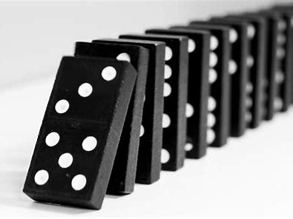
A proof by induction works like dominoes falling: If you show that the first domino falls and that each domino after that falls, you know that all the dominoes will fall. This means we will first test our base case, which is the first domino, before showing that each domino thereafter. Remember, we want to show that for any $2^{n}×2^{n}$ grid with a hole in it, you can fill it completely with L-shaped blocks.
In this investigation, our base case is where n = 1, and we know that this is trivially true:

We have therefore shown that the first domino falls, so let’s show that each domino hits the next.
Induction Hypothesis: Assume that we can cover a $2^{n-1}×2^{n-1}$ board with L-shaped pieces except for one chosen square. This is assuming that we can cover a quarter of the grid (with the hole) required with these pieces.

Induction Step: This is the key part. Divide the 2^{n} × 2^{n} board into four 2^{n−1} × 2^{n−1} square quadrants. One quadrant contains the square we want to leave uncovered by our pieces, and by the induction hypothesis we can cover this quadrant, except for the one square, with L-shaped pieces.
We know then that by adding another piece in the centre to cover the three quadrants without the hole, we create three 2^{n−1} × 2^{n−1} quadrants that we know we can cover with a single piece (from our hypothesis). This shows that if the domino before falls, the next one will also fall.
Finally, because it works for n = 1, it must work for n = 2 and therefore n = 3 and so on forever and ever. This means that for all positive integer values of n, it is possible to fit these L-shaped blocks in if the grid has a hole literally anywhere. Great job, you just learned the basics of proof by induction!

Game Theory

The Ultimatum Game
Imagine that someone offers you and some other anonymous person $100 to share.

The rules are strict and known to both players.
- The two of you are in separate rooms and cannot exchange information.
- A coin toss decides which of you will propose how to share the money.
- If you are the proposer you can make a single offer of how to split the sum, and the other person—the responder—can say yes or no.
- If the responder’s answer is yes, the deal goes ahead.
- If the answer is no, neither of you gets anything. In both cases, the game is over and will not be repeated.

What will you do?

I will be randomly assigning you into pairs. (Use Team Picker Wheel - Randomize a List of Names into Group) When your pair appears on screen, the first person will be the proposer, the second will be the responder. The proposer can then tell the responder their offer. What does the responder decide?

Notes from Khan Academy:
Instinctively, many people feel they should offer 50 percent, because such a division is “fair” and therefore likely to be accepted. More daring people, however, think they might get away with offering somewhat less than half of the sum.
You may not be surprised to learn that two-thirds of the offers are between 40 and 50 percent. Only four in 100 people offer less than 20 percent. Proposing such a small amount is risky, because it might be rejected. More than half of all responders reject offers that are less than 20 percent. But why should anyone reject an offer as “too small”? The responder has just two choices: take what is offered or receive nothing. The only rational option for a selfish individual is to accept any offer. A selfish proposer who is sure that the responder is also selfish will therefore make the smallest possible offer and keep the rest. This game-theory analysis, which assumes that people are selfish and rational, tells you that the proposer should offer the smallest possible share and the responder should accept it. But this is not how most people play the game.
The scenario just described, called the Ultimatum Game, was devised some twenty years ago. Experimenters subsequently studied the Ultimatum Game intensively in many places using diverse sums. The results proved remarkably robust. Behavior in the game did not appreciably depend on the players’ sex, age, schooling, or numeracy. Moreover, the amount of money involved had surprisingly little effect on results. Yet the range of players remained limited, because the studies primarily involved people in more developed countries and often university students.
Recently, a cross-cultural study in fifteen small-scale societies showed that there were sizable differences in the way some people play the Ultimatum Game. Within the Machiguenga tribe (from the Amazon) the mean offer was considerably lower than in typical Western-type civilizations—26 percent instead of 45 percent. Conversely, many members of the Au tribe (from Papua New Guinea) offered more than 50 percent. Cultural traditions in gift giving, and the strong obligations that result from accepting a gift, play a major role among some tribes, such as the Au. Yet despite these cultural variations, the outcome was always far from what rational analysis would dictate for selfish players. Most people all over the world place a high value on fair outcomes.
For a long time, theoretical economists postulated a being called Homo economicus—a rational individual relentlessly bent on maximizing a purely selfish reward. But the lesson from the Ultimatum Game and similar experiments is that real people are a crossbreed of H. economicus and H. emoticus, a complicated hybrid species that can be ruled as much by emotion as by cold logic and selfishness. An interesting challenge is to understand how Darwinian evolution would produce creatures instilled with emotions and behaviors that do not immediately seem geared toward reaping the greatest benefit for individuals or their genes.

The Prisoner’s Dilemma
The label "prisoner's dilemma" may be applied to any situation in which two entities could gain important benefits from cooperating or suffer from failing to do so but find it difficult or expensive to coordinate their activities.

Two members of a criminal gang are arrested and imprisoned. Each prisoner is in solitary confinement with no means of speaking to or exchanging messages with the other. The police admit they don't have enough evidence to convict the pair on the principal charge. They plan to sentence both to a year in prison on a lesser charge. Simultaneously, the police offer each prisoner a bargain. If he testifies against his partner, he will go free while the partner will get ten years in prison on the main charge. Oh, yes, there is a catch ... If both prisoners testify against each other, both will be sentenced to two years in jail. The prisoners are given a little time to think this over, but in no case may either learn what the other has decided until he has irrevocably made his decision. Each is informed that the other prisoner is being offered the very same deal. Each prisoner is concerned only with his own welfare—with minimizing his own prison sentence.

Students (the criminals) will be randomly paired up. What should you decide to do?
Use Team Picker Wheel - Randomize a List of Names into Group to assign pairings. Have these displayed on the screen and write up the result of each pair.
Discuss what happened.
Run this experiment a few times and see what happens. I would expect more of the students to testify against each other. This will result in them settling into the Nash Equilibrium. This is a position in the game where neither person can improve their situation if just they change their strategy. However, it is not the optimal outcome in the game.

In this diagram, you can see all of the possible outcomes. The optimal would be for both people to Deny, but this is not a stable position for the system, because a person can improve their position by changing their strategy. For example, if Al and Bob both denied but Al changed his mind it would improve his decision.
The position where both testify is a Nash Equilibrium as neither can improve their position by changing their strategy if the other person remains constant.

Videos on this:
Prisoners' dilemma and Nash equilibrium (video) | Khan Academy
More on Nash equilibrium (video) | Khan Academy

Game Theory in Business: Coca-Cola vs Pepsi
In this activity we are considering the difference between a one-time game and a repeated game.
You will compete in groups of four, made up of two pairs. One pair will represent Pepsi and one will represent Coca-Cola. The purpose of the game is to make the most money over time.
Each company can do one of two things each round: keep prices the same, or lower prices in a surprise sale. In the table below you can see the results of the two actions by each company.
Important: you do not know how long the game will be played for!
 |  | Coca-Cola
 |  | Lower prices | Keep current prices
Pepsi | Lower prices | Both companies earn  $5 million | Coca-Cola: $3 million  Pepsi: $15 million
 | Keep current prices | Coca-Cola: $15 million  Pepsi: $3 million | Both companies earn  $10 million

At the start of a round, each pair discusses whether they want to keep prices the same or to lower prices and have a surprise sale. They write this down on a piece of paper. Once each pair/company has decided on their strategy for the round, they present their strategies to the other company. Calculate the resulting earnings for each company. Keep a record of how much you earn each round.
At the end of the game, the company with the most money wins.
Discuss what strategies pairs followed. What did they notice? Did they behave differently from if it had been a one-time game?

Coca-Cola vs Pepsi worksheet
Round | Strategy | Earnings
1
2
3
4
5
6
7
8
9
10
11
12
13
14

The red black game
Split the class into two teams. Each round, one team will go out of the room so that both teams can discuss their decision for that round. The decision is whether to vote red or black.
Scoring
- If Team 1 votes black and Team 2 votes black both teams get plus 3 points.
- If Team 1 votes black and Team 2 votes red, Team 1 gets minus 5 and Team 2 gets plus 5.
- If Team 1 votes red and Team 2 votes black, Team 1 gets plus 5 and Team 2 gets minus 5.
- If Team 1 votes red and Team 2 votes red, Team 1 gets minus 3 points and Team 2 gets minus 3 points.
The object of the game is to get the most plus points possible.
- In the third frame each team gets double points.
- And in the sixth frame each team gets triple points for whatever they score.

How to Play
When we break up into the two teams and Team 2 goes out into the hall you will have three minutes in which to vote for each frame.
Everyone must vote in each frame and the majority vote wins.
There is no passing on voting. Everyone must vote in each frame.
Each team must elect a leader. The leader will count the votes, mark down what the vote is and tally the score.
Both teams must vote in one frame at a time.
You cannot move on to the next frame until each team has voted and the vote has been communicated back and forth between the two teams.
After each team has voted, they write their decision on a piece of paper and hand it to the teacher. The teacher then announces the decisions and the result of that round.

Predicting half of the average
Split the class into two groups. The groups will alternate playing, and in those rounds where they are not playing they should be looking at what is happening with the other group and trying to work out a strategy.
Each person will have a blank piece of paper with their name on it. Each round, they write a whole number from 0 to 100 on it. The teacher collects the papers and calculates the average of the numbers on them. The winner is the student whose number is closest to half the average.
Play multiple rounds, allowing students time to consider possible strategies each time. However, do not allow group discussion during or between rounds.
Note: the Nash equilibrium in this game is zero. Because the average can never exceed 100, half of the average can never exceed 50. Therefore, any choice above 50 is dominated by 50. This then means that the average can never exceed 50, therefore half of the average cannot exceed 25. And so on. This is the concept of iterated dominance.
Once you have played a number of rounds, hold a group discussion with the whole class. Identify these points:
- What is the Nash equilibrium in this game?
- Describe the concept of iterated dominance.
- Getting close to the Nash equilibrium by the experience of playing the game. However, zero is rarely attained (unless the whole group cooperates and chooses zero). Is this a flaw in the theory or just that the theory gives a good approximation?
- The idea that if one has a good reason to believe that others will not be playing their Nash equilibrium strategies, then one’s optimal choice will also differ from one’s own Nash equilibrium strategy.
Finish by watching this video on k-level thinking: Game theory challenge: Can you predict human behavior? - Lucas Husted - YouTube

Guessing half the average – worksheet
Each round, write your name and your guess. Cut it out and hand it to the teacher.
Name | Guess

Follow-up – predicting the average
Change the game so that students are now trying to guess the average of all the numbers. This is a metaphor for the stock market, where everyone is trying to guess what everyone else is trying to guess.
This game has multiple Nash equilibria, each sustained by its own bootstraps. Stress the importance of this game in the students’ own lives. Part or even all of their retirement funds are likely to be in individual accounts. When they decide how to invest this sum, they will have to think through the question: Will the historical pattern of returns and volatility of various assets persist when everyone makes the same decisions that I am now contemplating? This interaction between individual choice (strategy) and aggregate outcomes (equilibrium) comes naturally to someone who is trained to think in game theories, but others are often liable to forget the effect of everyone’s simultaneous choices. In the context of saving for retirement, this can be very costly.

The Centipede Game
This is a modified version of the classic game theory game, designed for a high school class.
Students will be competing in pairs, but also against everyone else in the class. There are two winners at the end - the person who has the most points at the end of the game and the one who comes second. Typically, the game has 100 rounds (hence its name), but it might be better to keep this shorter: 10-20 rounds instead.
At the start of each round, the pot of available points is increased by 2. The split of the pot changes each round, alternating who gets the majority. Players alternate each round in making a decision: end the game and take the points split at that point or continue the game into the next round.
Round | 1 | 2 | 3 | 4 | … | 9 | 10
Player making decision | 1 | 2 | 1 | 2 |  | 1 | 2
Points split | 2, 0 | 1, 3 | 4, 2 | 3, 5 |  | 10, 8 | 9, 11

For example, in the first round player 1 can decide to take the 2 points and give player 2 zero points, or pass the decision onto player 2. If they do this, the pot increases to 4 points. Player 2 can now decide whether to take the pot as it is, getting 3 points for themselves and giving only 1 point to player 1. If they pass, the pot increases and the decision passes back to player 1.
At the end of each round, roll a dice. If it comes up with a 6, the game ends and any players who haven’t ended will get zero points. The winner will therefore be the player who most recently decided to end the game. However, second place may not go to their partner, it could go to the player who ended the game in the previous round. Players can discuss and strategise between moves.
The game continues for as many rounds as necessary. At the end of the game, discuss who got the most points. What strategies did they play?
Allow students to discuss strategies with their partner, then repeat the game.
Simon Sinek video on what game theory teaches us about war:
What game theory teaches us about war | Simon Sinek - YouTube
Great videos related to game theory:
Can you solve the pirate riddle? - Alex Gendler - YouTube

Why do competitors open their stores next to one another? - Jac de Haan - YouTube

